Fake News Detection on Social Media Platform

Final Year Project

2018-2022

A project submitted in partial fulfillment of the degree of

BS in Computer Science



Submitted to

Mr. Shoaib Malik

Department of Computer Science

Faculty of Computing & Artificial Intelligence (FCAI)

Air University, Islamabad

|  |  |  |  |  |  |
| --- | --- | --- | --- | --- | --- |
| Type (Nature of project) | | | [ ] Development [ ✓ ] Research | | |
| Area of specialization | | | [ ] WebApp [ ] Mobile App  [ ✓ ] AI based [ ] Embedded System | | |
| FYP ID | | | CS-SP-21-25 | | |
| **Project Group Members** | | | | | |
| Sr.# | Reg. # | Student Name | | Email ID | \*Signature |
| (i) | 180978 | Maryam Munir | | [180978@Students.au.edu.pk](mailto:180978@Students.au.edu.pk) |  |
| (ii) | 181030 | Qurat ul Ain | | [181030@Students.au.edu.pk](mailto:181030@Students.au.edu.pk) |  |
| (iii) |  |  | |  |  |

\*The candidates confirm that the work submitted is their own and appropriate credit has been given where reference has been made to work of others

# Plagiarism Certificate

This is to certify that, I Maryam Munir S/D of Muhammad Munir , group leader of FYP under registration no. 180978 at Computer Sciences Department, Air University. I declare that my FYP report is checked by my supervisor.

Date:\_\_\_\_\_\_\_\_\_\_\_\_\_\_ Name of Group Leader: \_\_\_\_\_\_\_\_\_\_\_\_\_\_\_\_\_\_\_\_\_ Signature:\_\_\_\_\_\_\_\_

Name of Supervisor: Mr. Muhammad Qasim Riaz Co-Supervisor: (Not Allocated)

Designation: Lecturer Designation: (N/A)

Signature: \_\_\_\_\_\_\_\_\_\_\_\_\_\_\_\_ Signature: \_\_\_\_\_\_\_\_\_\_\_\_\_\_\_\_\_

HoD: Dr. Awais Ahmad

Signature: \_\_\_\_\_\_\_\_\_\_\_\_\_\_\_

**Fake News Detection on Social Media Platform**

**Change Record**

|  |  |  |  |  |
| --- | --- | --- | --- | --- |
| **Author(s)** | **Version** | **Date** | **Notes** | **Supervisor’s Signature** |
|  |  |  |  |  |
|  |  |  |  |  |
|  |  |  |  |  |
|  |  |  |  |  |
|  |  |  |  |  |
|  |  |  |  |  |
|  |  |  |  |  |
|  |  |  |  |  |
|  |  |  |  |  |
|  |  |  |  |  |

**APPROVAL**

|  |  |  |
| --- | --- | --- |
| **Project Supervisor** | | |
| Name:\_\_\_\_\_\_\_\_\_\_\_\_\_\_\_\_\_\_\_\_\_\_\_\_\_\_\_\_\_\_ | |  | | |
| Date:\_\_\_\_\_\_\_\_\_\_\_\_\_\_\_\_\_\_\_\_\_\_\_\_\_\_\_\_\_\_\_ | | Signature:\_\_\_\_\_\_\_\_\_\_\_\_\_\_\_\_\_\_\_\_\_\_\_\_\_ | | |
| **Project Manager** | | | |
| Date:\_\_\_\_\_\_\_\_\_\_\_\_\_\_\_\_\_\_\_\_\_\_\_\_\_\_\_\_\_\_\_ | Signature:\_\_\_\_\_\_\_\_\_\_\_\_\_\_\_\_\_\_\_\_\_\_\_\_\_\_ | | |

|  |  |
| --- | --- |
| **Chair Department** | |
|  |  |
| Date:\_\_\_\_\_\_\_\_\_\_\_\_\_\_\_\_\_\_\_\_\_\_\_\_\_\_\_\_\_\_\_ | Signature:\_\_\_\_\_\_\_\_\_\_\_\_\_\_\_\_\_\_\_\_\_\_\_\_\_\_ |

# Acknowledgements

We take this opportunity to express our sincere gratitude to **Sir Shoaib Malik** for his valuable guidance in this PROJECT REPORT without which the PROJECT REPORT would not have been completed. We are very much grateful to him for his untiring assistance in this report and he has been encouraging us in eliminating the errors. The report has been developed as a result of his valuable advice

We are thankful to our classmates and friends for their support and being such a good company. We extend our gratitude to researches and scholars whose papers and thesis have been utilized in our report.

Abstract

In our modern era where the internet is ubiquitous, everyone relies on various online resources for news. Along with the increase in the use of social media platforms like Facebook, Twitter,Youtube etc. news spread rapidly among millions of users within a very short span of time. The spread of fake news has far-reaching consequences like the creation of biased opinions to swaying election outcomes for the benefit of certain candidates. Moreover, spammers use appealing news headlines to generate revenue using advertisements via click-baits and fake articles. In this paper, we aim to perform fake news detection on social media platform on academic social media content by using available Checker Dataset for video and text classification with the help of existing Natural Language Processing and Machine Learning techniques. We aim to provide the user with the ability to classify the news as fake or real and also check the authenticity of the scientific content. In this paper, we have used Logistic Regression Model which gives us 82.25% accuracy.

# Table of Contents

[Fake News Detection on Social Media Platform i](#_Toc103424641)

[Final Year Project i](#_Toc103424642)

[2018-2022 i](#_Toc103424643)

[BS in Computer Science i](#_Toc103424644)

[\*The candidates confirm that the work submitted is their own and appropriate credit has been given where reference has been made to work of others ii](#_Toc103424645)

[Plagiarism Certificate iii](#_Toc103424646)

[Acknowledgements vi](#_Toc103424648)

[Table of Contents viii](#_Toc103424650)

[Chapter 1 16](#_Toc103424654)

[Introduction & Background 16](#_Toc103424655)

[1.1. Background 17](#_Toc103424656)

[1.2. Motivations and Challenges 17](#_Toc103424657)

[1.3. Goals and Objectives 18](#_Toc103424658)

[1.4. Literature Review/Existing Solutions 18](#_Toc103424659)

[1.5. Gap Analysis 19](#_Toc103424660)

[1.6. Proposed Solution 19](#_Toc103424661)

[1.7. Project Plan 19](#_Toc103424662)

[1.7.1. Work Breakdown Structure 20](#_Toc103424663)

[1.7.2. Roles & Responsibility Matrix 20](#_Toc103424664)

[1.7.3. Gantt Chart 22](#_Toc103424665)

[Chapter 2 23](#_Toc103424667)

[Software Requirement Specifications 23](#_Toc103424668)

[2.1. Introduction 24](#_Toc103424670)

[2.1.1. Purpose 24](#_Toc103424672)

[2.1.2. Intended Audience and Reading Suggestions 24](#_Toc103424674)

[2.1.3. Product Scope 24](#_Toc103424675)

[2.2. Overall Description 25](#_Toc103424676)

[2.2.1. Product Perspective 25](#_Toc103424677)

[2.2.2. User Classes and Characteristics 25](#_Toc103424678)

[2.2.3. Operating Environment 26](#_Toc103424679)

[2.2.4. Design and Implementation Constraints 26](#_Toc103424680)

[2.2.5. Assumptions and Dependencies 26](#_Toc103424681)

[2.3. External Interface Requirements 26](#_Toc103424682)

[2.3.1. Hardware Interfaces 26](#_Toc103424684)

[2.3.2. Software Interfaces 27](#_Toc103424685)

[2.3.3. Communications Interfaces 27](#_Toc103424686)

[2.4. System Features 28](#_Toc103424687)

[2.4.1. Fake News Detection 28](#_Toc103424688)

[2.4.1.1. Description and Priority 28](#_Toc103424689)

[2.4.1.2. Stimulus/Response Sequences 28](#_Toc103424690)

[2.4.1.3. Functional Requirements 28](#_Toc103424691)

[2.5. Nonfunctional Requirements 30](#_Toc103424697)

[2.5.1. Performance Requirements 30](#_Toc103424698)

[2.5.2. Safety Requirements 30](#_Toc103424699)

[2.5.3. Security Requirements 30](#_Toc103424700)

[2.5.4. Usability Requirements 30](#_Toc103424701)

[2.5.5. Reliability Requirements 30](#_Toc103424702)

[2.5.6. Maintainability/Supportability Requirements 30](#_Toc103424703)

[2.5.8. Efficiency Requirements 30](#_Toc103424705)

[2.6. Domain Requirements… 31](#_Toc103424706)

[Chapter 3 32](#_Toc103424707)

[Literature Review 32](#_Toc103424708)

[3.1.1. Existing System 35](#_Toc103424711)

[3.1.2. Need of a New System 35](#_Toc103424713)

[3.1.3. Problems Definition 35](#_Toc103424715)

[3.2. Formatting of Equations 35](#_Toc103424716)

[Chapter 4 1](#_Toc103424718)

[Use Case Analysis 1](#_Toc103424719)

[4.1. Use Case Model 2](#_Toc103424722)

[4.2. Use Cases Description 3](#_Toc103424723)

[Chapter 5 8](#_Toc103424724)

[Proposed Approach 8](#_Toc103424725)

[5.1. Dataset Exploration 9](#_Toc103424734)

[5.2. Data Augmentation and Pre-Processing 10](#_Toc103424735)

[Chapter 6 11](#_Toc103424736)

[Implementation & Results 11](#_Toc103424737)

[6.1 Different components of your proposed approach 13](#_Toc103424738)

[6.2 Implementation of proposed approach 13](#_Toc103424739)

[6.3 Deployment Environment 15](#_Toc103424740)

[6.5 Best Practices / Coding Standards 18](#_Toc103424749)

[Chapter 7 20](#_Toc103424751)

[Business Plan 20](#_Toc103424752)

[**Chapter 7:** Business Plan 21](#_Toc103424753)

[7.1 Business Description 21](#_Toc103424757)

[7.2 Market Analysis & Strategy 21](#_Toc103424758)

[7.3 Competitive Analysis 21](#_Toc103424759)

[7.4 Products/Services Description 21](#_Toc103424760)

[7.5 SWOT Analysis 22](#_Toc103424761)

[Chapter 8 22](#_Toc103424762)

[Conclusion & Future Work 22](#_Toc103424763)

[**Chapter 8:** Conclusion & Future Work 23](#_Toc103424764)

[8.1 Achievements and Improvements 23](#_Toc103424766)

[8.3 Future Enhancements/Recommendations 24](#_Toc103424768)

[Chapter 9 25](#_Toc103424769)

[Paper Writing 25](#_Toc103424770)

[9.1. Paper Writing 26](#_Toc103424775)

[Appendices 27](#_Toc103424776)

[Appendix A: Information / Promotional Material 28](#_Toc103424777)

[References 29](#_Toc103424778)

# 

# Chapter 1

# Introduction & Background

Chapter 1: Introduction

In this chapter, we are going to discuss about the introduction of our project ie fake news detection. We will discuss about different modules of our project here, most probably its literature review. About how we started and what was the motivation behind doing this particular project, its goals and achievements, and also the challenges. We will discuss them one by one here.

## Background

As an increasing amount of our lives is spent interacting online through social media platforms, more and more people tend to hunt out and consume news from social media instead of traditional news organizations. The explanations for this alteration in consumption behaviors are inherent within the nature of those social media platforms: (i) it's often more timely and fewer expensive to consume news on social media compared with traditional journalism , like newspapers or television; and (ii) it's easier to further share, and discuss the news with friends or other readers on social media. However, because it's inexpensive to supply news online and far faster and easier to propagate through social media, large volumes of faux news, i.e., those news articles with intentionally false information, and also create Clickbait thumbnails on video-sharing platforms (e.g., YouTube, Dailymotion) that are small catchy images that are designed to entice users to click to view the linked videos are produced online for a spread of purposes, like financial and political gain. Fake news detection system not only plays significance role in general social media news but also in academic social media content. To solve this particular problem, we are working on the project to detect the fake news and develop/evaluate a stance detection system on the recently released

Checker Fake Videos Detection Dataset. To develop/evaluate fake news detection system based on existing machine learning approaches.

## Motivations and Challenges

The phenomenal growth in web information has nourished research endeavors for automatic fact checking, or fake news and/or misinformation detection. First, fake news can shatter the authenticity equilibrium of the news ecosystem for instance. Understanding the truth of new and message with news detection can create positive impact on the society. Detecting the academic social media news by using the existing machine learning models is the biggest challenge for us as it has not been given much attention as other social media platforms are given.

## Goals and Objectives

Our goal is to design a system that will detect the fake news by taking textual or video data as input and will classify as fake or authentic news. The main objective of this project or research is to check whether existing technologies can be applied to judge the authenticity of scientific content.

## Literature Review/Existing Solutions

There is a growing interest in studying misinformation on social media. One line of research focuses on the detection of articles and fake videos. Online content creators use such fake titles to attract attention and lure visitors to click on a hyperlink of a target landing web page, which may contain fake content. These titles become a popular medium for mass propagation of false news. In videos detection research, to 4 T. Xie et al. explore what makes a headline “clickbaity”, conduct three clickbait studies. Moreover, further studies improves those detectors by augmenting their training dataset with synthetic clickbait headlines. In this work, we are not only working on videos detection but also on the articles detection to classify them as fake or real. CHECKER: Detecting Clickbait Thumbnails with Weak Supervision and Co-teaching, is the latest video detection research done in which they have used unlabeled data based on characteristics of clickbait thumbnails. On the other hand, if we talk about the existing research of text classification, then we will get to know that the recently released Fake News Challenge Stage 1 (FNC-1) dataset introduced the benchmark FNC stage-1: stance detection task was used in Fake News Detection: A Deep Learning Approach which is the latest research paper published in December 2021 in which they have used deep learning approach and got 94.2% accuracy.

## Gap Analysis

We have already seen some good research that shows machine learning algorithms can successfully detect fake news in real life and in real world situations even, but it did not catch the focus of the audio detection. This needs to be done because it can help us with many tasks such as social media posts and we could already do a great job on social media in the field of fake news detection. We have already demonstrated that fake news detection is an important goal of real users. Therefore we do not take on such a long training course in order to make it more interesting and useful for the real world.

## Proposed Solution

Our proposed solution is that we are trying to increase the accuracy of research paper, Fake News Detection: A Deep Learning Approach which is the latest research paper published in December 2021.They have used deep neural networks approach to get the 94.2 % accuracy and we are trying to get maximum accuracy by using machine learning techniques. We have used Checker dataset for both video to text classification and text to text classification by using following machine learning algorithms:

* Logistic Regression
* Decision Tree Classifier
* Support Vector Machine
* Naïve Bayes Algorithm
* Random Forest Classifier

## Project Plan

We had divided our project into three main components :

* FYP – 1
* FYP – 2
* FYP – 3

At every phase of this project, we had just set some objectives to achive our goal and to help us in getting more knowledge about it to overcome the challenges in the project. The main components of project plan are :

* **Scope** – To develop/evaluate a stance detection system on the recently released Fake News Challenge Stage 1 (FNC-1) dataset introduced the benchmark FNC stage-1: stance detection task.
* **Budget** – As our project is research based, so till now we had not invested anything to complete our project.
* **Timeline** – Timeline of each phase of the project differs and is shown in the ghantt chart in the below section 1.7.3.

## Work Breakdown Structure

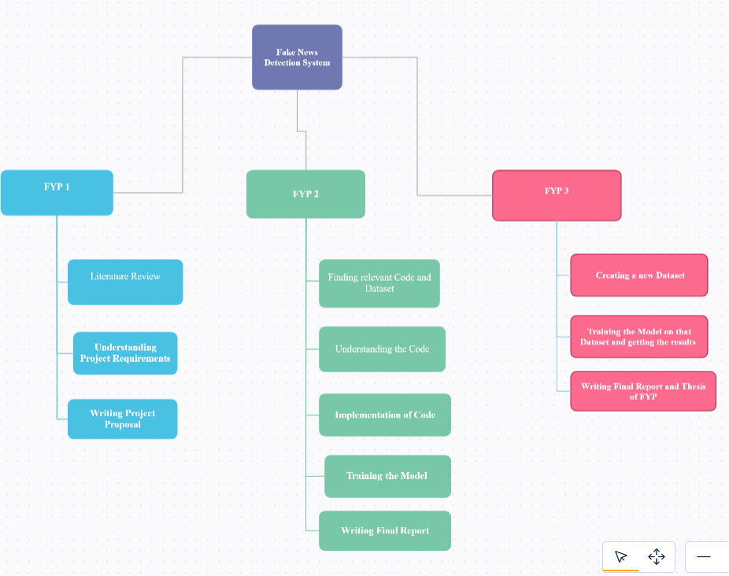

## Roles & Responsibility Matrix

|  |  |  |
| --- | --- | --- |
| Responsibilities | Role 1 – Maryam Munir | Role 2 – Qurat ul Ain |
| Literature Review | ✔ | ✔ |
| Understanding Project Requirements | ✔ | ✔ |
| Writing Project Proposal | ✔ | ✔ |
| Finding Relevant Code | ✔ | X |
| Finding Relevant Dataset | X | ✔ |
| Understanding Code | ✔ | ✔ |
| Implementation of Code | ✔ | ✔ |
| Training the Model | ✔ | ✔ |
| Writing the Final Report | ✔ | ✔ |
| Creating New Dataset | ✔ | ✔ |
| Training the Model on new dataset | ✔ | ✔ |
| Writing Thesis of FYP | ✔ | ✔ |

## Gantt Chart

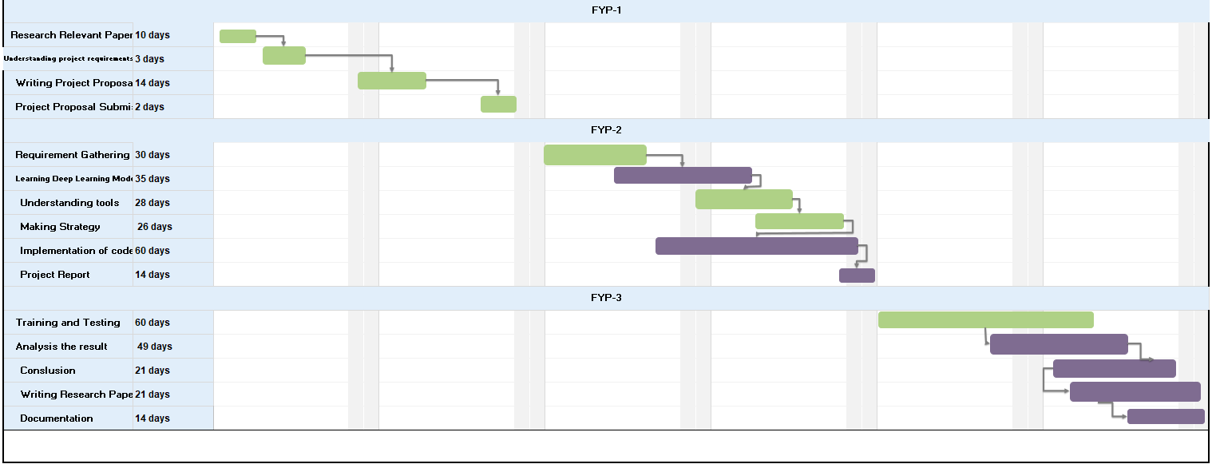

# Chapter 2

# Software Requirement Specifications

**Chapter 2: Software Requirement Specifications**



## Introduction

A software requirements specification is the basis for the entire project. It lays the framework that every team involved in development will follow. It's used to provide critical information to multiple teams — development, quality assurance, operations, and maintenance. Below are some of its main components:

## Purpose

In this document, we will be covering the software requirements of our fake news detection system in which we are using Checker dataset. The scope of our project is to develop/evaluate a stance detection system on the recently released Checker Dataset. There are 2 modules of our system i.e Video Classification and text classification for which we used word count based models (e.g. bag of words (BOW) , bag of n-grams ) which will create data features, which are then used as an input to the machine learning techniques for classifying the news in given dataset.

## 

## Intended Audience and Reading Suggestions

Our intended audience includes researchers, teachers, documentation writers and project managers.

## Product Scope

To develop/evaluate a stance detection system on the recently released Checker Fake Videos Detection. Our goal is to design a system that will detect the fake news by taking textual or video data as input and will classify as fake or authentic news. The main objective of this project or research is to check whether existing technologies can be applied to judge the authenticity of scientific content.

## Overall Description

## Product Perspective

In this project, we are follow-on an existing work on fake news detection. In addition to their work, we will test whether the existing techniques would be applicable on academic social media content or not. Our system will be added to other larger system i.e. an application named as “Explore it” on which are other fellows are working, that is an incentive based social media platform for researchers, students, teachers and scholars. The main goal of Explore it is to connect the people who are enthusiastic about learning and contributing to the community. These users will be sharing a lot of data on daily basis, so data should be real to ensure the reliability of app. For this problem, our system will be helping them to detect the fake data and filter out the real data.

Here is the flow diagram of whole system:

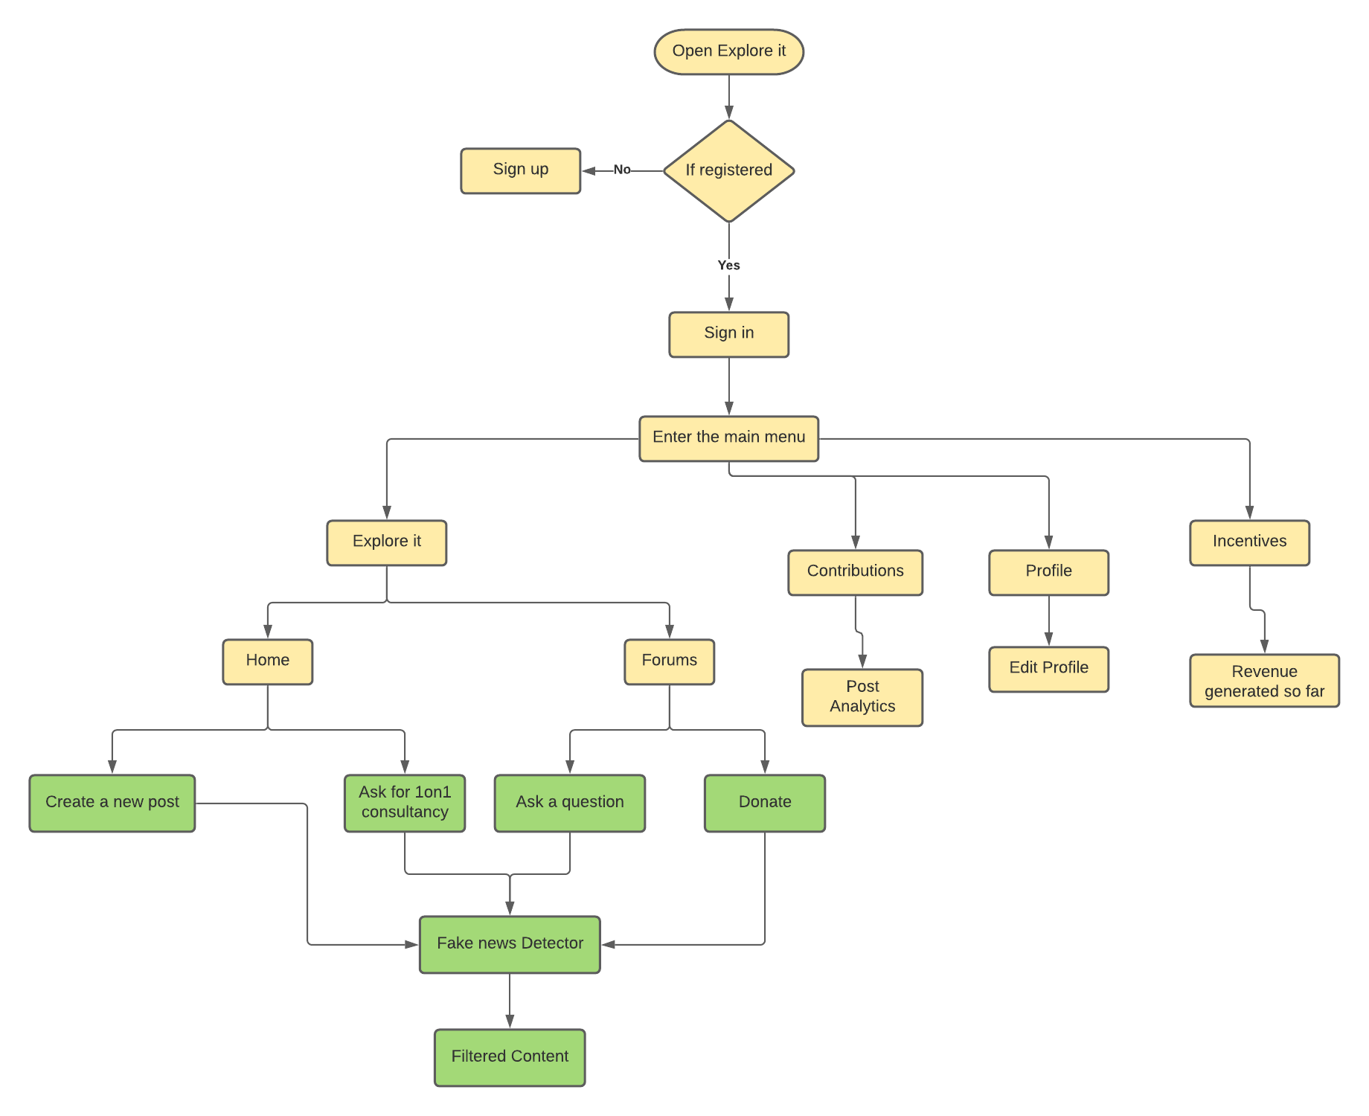

## User Classes and Characteristics

Following are the user classes and their characteristics for the system:

**Researchers:** Whenever the researchers will upload any data or share any scientific content, it will be classified as fake or real by the system. The technical experience of these users should not matter as the system will be straightforward and easy to use.

**System Developers/ Project Handlers:** They will be the primary maintainers of the application and may have to perform some administrative functions relating to the academic content. They will have a technical background.

## Operating Environment

Our system will be run on a web application for testing.

## Design and Implementation Constraints

Following are some constraints of our system in application:

* The system will detect only in English Language.
* The system will ensure the authenticity of academic social media content.

## Assumptions and Dependencies

The following are main assumptions,

* The system totally depends on type of dataset being loaded into it.
* The system assumes that the dataset files are in .txt format.

## External Interface Requirements

## 

## Hardware Interfaces

There is no direct hardware interface specifically for our system. The android application runs on an application server hosted in-house on enterprise hardware.

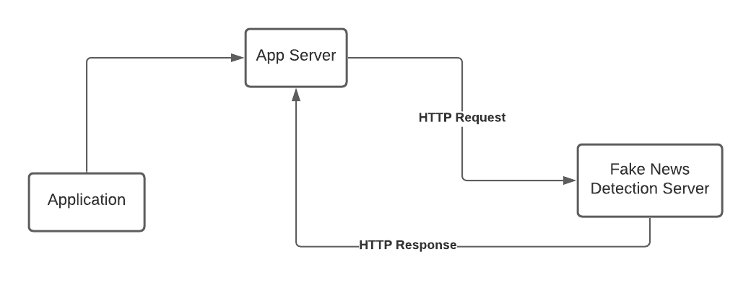

## Software Interfaces

Following are the details of software, tools and libraries that we have used in our system:

|  |  |
| --- | --- |
| **Software used** | **Description** |
| Operating System | We have chosen Windows operating system for its best support and user-friendliness. |
| Database | For securing the data of researchers, we have chosen MS SQL Server. |
| Pycharm | We have used pycharm community edition 2021.2.2 as a tool to develop our system. |
| Python | We have used python language to train our model. |

## Communications Interfaces

Internet Protocol (IP) shall be used by the software interfaces to connect to the internet while sharing the data.

## System Features

Our system main feature is to detect the fake news on academic social media content:

## Fake News Detection

## Description and Priority

This feature will help us to detect the scientific content by using word count based models (bag of words (BOW) and bag of n-grams). This feature has highly priority as it is the only main purpose of our project.

## Stimulus/Response Sequences

* User will share any data or post related to scientific social media news.
* System will collect the data and start cleaning it.
* After cleaning the data, it will extract features and classify the data by using logistic regression.
* After classifying the data as fake or real, the system will filter out the real news and then share them with user.

## Functional Requirements

**REQ-SF1-1: Data Collection**

The dataset which we had used is Checker Dataset for stance detection.

**REQ-SF1-2: Data Pre-Processing**

Pre-Processing is done before training and testing the data so that the data scientists find it easy to understand feed it into the machine learning model i.e. logistic regression.

**REQ-SF1-3: Dataset Splitting**

The dataset should be splitted into 2 parts i.e. training and testing data.

**REQ-SF1-4: Model Training**

After the dataset has been pre-processed, which he has then processed into train and test the data is ready for model training.

**REQ-SF1-5: Model Evaluation and Testing**

The goal of this process is to develop a simple model that would be classifying the scientific data as fake or real after applying existing machine learning techniques.

## Nonfunctional Requirements

## Performance Requirements

Performance requirements depends on the type of data that is being used by the researcher. If it is in the form of text it might take less time to detect but if it is in the form of audio or video it might take more time to classify the content.

## Safety Requirements

If there is extensive damage to a wide portion of the database due to high load of dataset, the recovery method restores a past copy of the database that was backed up to archival storage (typically tape) and reconstructs a more current state by reapplying or redoing the operations of committed transactions from the backed up log, up to the time of failure.

## Security Requirements

Input Data should be validated for SQL injection scenarios. Input should be sanitized before sending them to the upstream systems.

## Usability Requirements

The system is very easy to use and user don’t need any technical experience to use it.

## Reliability Requirements

Researchers can use the system 24 hours a day.

## Maintainability/Supportability Requirements

Due to any problem if data is lost, then we have a backup data which will be stored in our database system.

## Efficiency Requirements

The system responds fast in no time if data is in form of text but if data is in the form of audio or video then it might several minutes to detect

# Chapter 3

# Literature Review

**Chapter 3: Literature Review**

**1)Fake News Detection Using Naive Bayes Classifier-Mykhailo Granik, Volodymyr Mesyura.Published in the year in 2017 in Vinnytsia, Ukraine.**

The paper shows a simple approach for fake news detection using naive Bayes classifier. This approach was implemented as a software system and tested against a data set of Facebook news posts. We achieved classification accuracy of approximately 74% on the test set which is a decent result considering the relative simplicity of the model. This results may be improved in several ways, that are described in the article as well. Received results suggest, that fake news detection problem can be addressed with artificial intelligence methods.

**2) Fake News Detection-Akshay Jain, Amey Kasbe.Published in the year 2018 in Bhopal,India**

Information preciseness on Internet, especially on social media, is an increasingly important concern, but web-scale data hampers, ability to identify, evaluate and correct such data, or so called “fake news,” present in these platforms. In this paper, we propose a method for “fake news” detection and ways to apply it on Facebook, one of the most popular online social media platforms. This method uses Naive Bayes classification model to predict whether a post on Facebook will be labeled as REAL or FAKE. The results may be improved by applying several techniques that are discussed in the paper. Received results suggest, that fake news detection problem can be addressed with machine learning methods.

**3) Fake News Detection on Social Media:A Data Mining Perspective by Kai Shuy, Amy Slivaz, Suhang Wangy, Jiliang Tang , and Huan Liuy Computer Science & Engineering, Arizona State University, Tempe, AZ, USA**

Social media for news consumption is a double-edged sword. On the one hand, its low cost, easy access, and rapid dissemination of information lead people to seek out and consume news from social mediaOn the other hand, it enables the wide spread of \fake news", i.e., low quality news with intentionally false information. The extensive spread of fake news has the potential for extremely negative impacts on individuals and society. Therefore, fake news detection on social media has recently become an emerging research that is attracting tremendous attention. Fake news detection on social media presents unique characteristics and challenges that make existing detection algorithms from traditional news media ine\_ective or not applicable. First, fake news is intentionally written to mislead readers to believe false information, which makes it difficult and nontrivial to detect based on news content; therefore, we need to include auxiliary information, such as user social engagements on social media, to help make a determination. Second, exploiting this auxiliary information is challenging in and of itself as users' social engagements with fake news produce data that is big, incomplete, unstructured, and noisy. Because the issue of fake news detection on social media is both challenging and relevant, we conducted this survey to further facilitate research on the problem. In this survey, we present a comprehensive review of detecting fake news on social media, including fake news characterizations on psychology and social theories, existing algorithms from a data mining perspective, evaluation metrics and representative datasets. We also discuss related research areas, open problems, and future research directions for fake news detection on social media.

3. Previous Systems
   * 1. Existing System

We can get online news from different sources like social media websites, search engine, homepage of news agency websites or the factchecking websites. On the Internet, there are a few publicly available datasets for Fake news classification like Buzzfeed News, LIAR , BS Detector,misinformation and FNC-1 etc. These datasets have been widely used in different research papers for determining the veracity of news. In the following sections, I have discussed in brief about the sources of the dataset used in this work.This Existing system can help us to trained our model using machine learning technique

* + 1. Need of a New System

As an increasing amount of our lives is spent interacting online through social media platforms, more and more people tend to hunt out and consume news from social media instead of traditional news organizations whether these news are from academic side or from entertainment point of view. For solving that problem we will use different machine learning models to make a system that will help us to detect the authenticity of news. We have used word count based techniques (e.g. bag of words(BOW), bag of ngram) which will create data features, which are then used as an input to the logistic regression for classifying the scientific content.

* + 1. Problems Definition

The increasingly rapid pace of spreading fake news is considered a problem in conjunction with the increasing number of people who are relying upon social media to get news. That earns widespread attention from research communities due to the negative impact and influence of fake news on public decisions. The project aims to illuminate the current research on fake news problem and the process of detecting the fake news especially in academic social networks.

* 1. Formatting of Equations

Here, we had used the logistic regression for classifying the content, which is also called the sigmoid function that was developed by statisticians to describe properties of population growth in ecology, rising quickly and maxing out at the carrying capacity of the environment. It’s an S-shaped curve that can take any real-valued number and map it into a value between 0 and 1, but never exactly at those limits.

sigmoid (Z) =1 / (1 + e^-z)

Hypothesis => Z = WX + B

hΘ(x)=sigmoid(Z)

# 

# Chapter 4

# Use Case Analysis

**Chapter 4: Use Case Analysis**

A use case analysis is the primary form for gathering usage requirements for a new software program or task to be completed. The primary goals of a use case analysis are: designing a system from the user's perspective, communicating system behavior in the user's terms, and specifying all externally visible behaviors.



## Use Case Model

**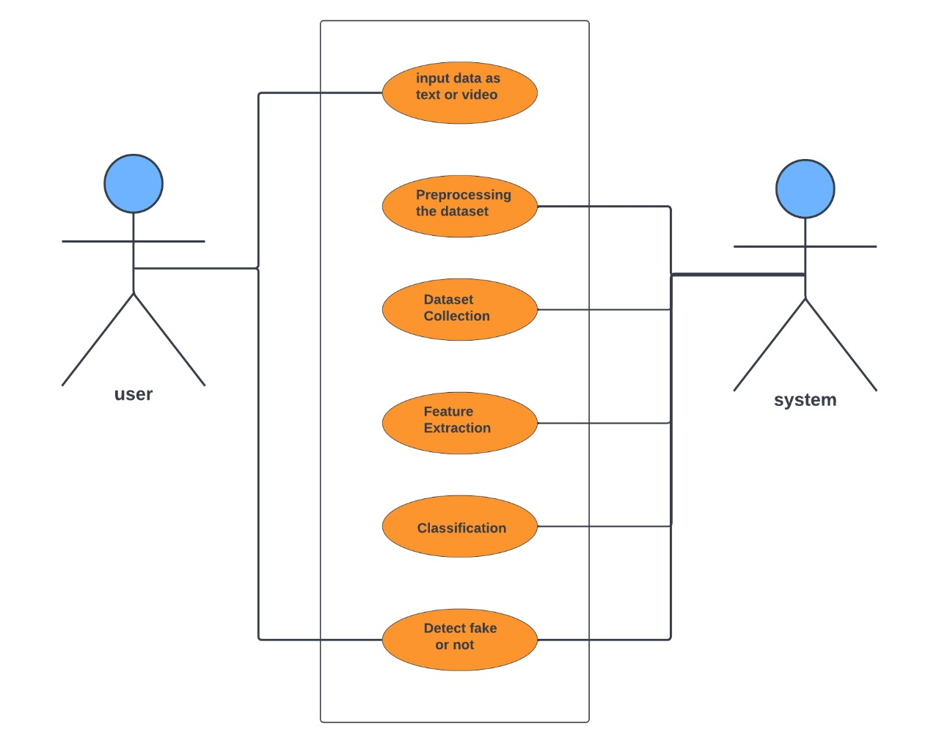**

**Figure 4.1: Use Case Diagram for Fake News Detection System**

## Use Cases Description

Our use case diagram contains 6 use cases for which 2 cases are for user/researcher and other 4 use cases are for admin. Firstly, the user will enter the data in any form (i.e video subtitles or text) then the system will get the data as input and will clean the dataset by pre-processing the dataset. After the pre-processing of dataset, the system will create data features by using word count based models (e.g bag of words (BOW) and bag of n-gram) .After creating the data features, the system will give these features to logistic regression model as an input which will classify the data as fake or authentic. Then the output data will be shared to user.

* + 1. **Use Case Function**

1. Input Data Function

|  |  |
| --- | --- |
| **Title** | Input data |
| **Requirement** | User must input the data in form of text |
| **Rational** | Login to the system |
| **Restriction or Risk** | Wrong or correct login sent to database |
| **Dependency** | Pc, Internet connection |
| **Priority** | Safety, timing |

Table 1.1: Input Data Function

**Use Case 1: Input Data**

|  |
| --- |
| **Input data** |
| **Actor** |
| * Researcher , Project Managers |
| **Preconditions** |
| * Must enter CNIC , username , password and email. * Must be a valid username and password. * Must be a valid CNIC |
| **Basic flow** |
| * Sign in to interact with system. * After entering into the system just input the dataset to classify it. |
| **Alternate flows** |
| * User don’t want to view result |
| **Post Condition** |
| * User must download the results and signout. |

Table 1.2: Input Data Function: UC1

1. **Dataset Collection Function**

|  |  |
| --- | --- |
| **Title** | Dataset collection |
| **Requirement** | Dataset should be in text format. |
| **Rational** | Dataset should be loaded into the system. |
| **Restriction or Risk** |  |
| **Dependency** | Pc, Internet connection |
| **Priority** | Safety, timing |

Table 2.1: Dataset Collection Function

**Use Case 2: Dataset Collection**

|  |
| --- |
| **Dataset Collection** |
| **Actor** |
| * Admin |
| **Preconditions** |
| * Must enter CNIC , username , password and email. * Must be a valid username and password. * Must be a valid CNIC |
| **Basic flow** |
| * Sign in to interact with system. * After the user had entered the dataset into the system, load these dataset files by importing csv and get the files into csv format. |
| **Alternate flows** |
| * Dataset is already in .csv format. |
| **Post Condition** |
| * Admin should keep an extra copy of collected data. |

Table 2.2: Dataset Collection Function: UC2

1. **Pre-Processing the Dataset Function**

|  |  |
| --- | --- |
| **Title** | Pre-processing the dataset |
| **Requirement** | Dataset should be in text format and must be collected to start pre-processing. |
| **Rational** | Dataset should be loaded into the system. |
| **Restriction or Risk** |  |
| **Dependency** | Pc, Internet connection |
| **Priority** | Safety, timing |

Table 3.1: Pre-processing the Dataset Function

**Use Case 3: Pre-Processing the Dataset**

|  |
| --- |
| **Pre-Processing the Dataset** |
| **Actor** |
| * Admin |
| **Preconditions** |
| * Must enter CNIC , username , password and email. * Must be a valid username and password. * Must be a valid CNIC |
| **Basic flow** |
| **Alternate flows** |
| * Dataset is already cleaned. |
| **Post Condition** |
| * Admin should keep an extra copy of clean data. |

**Table 3.2: Pre-processing the Dataset Function: UC3**

1. **Feature Extraction**

|  |  |
| --- | --- |
| **Title** | Feature extraction |
| **Requirement** | Dataset must be pre-processed and cleaned to be ready for the feature extraction. |
| **Rational** | Dataset should be loaded into the system. |
| **Restriction or Risk** |  |
| **Dependency** | Pc, Internet connection |
| **Priority** | Safety, timing |

Table 4.1: Feature Extraction Function

**Use Case 4: Feature Extraction**

|  |
| --- |
| **Feature Extraction** |
| **Actor** |
| * Admin |
| **Preconditions** |
| * Must enter CNIC , username , password and email. * Must be a valid username and password. * Must be a valid CNIC |
| **Basic flow** |
| * Sign in to interact with system. * After collecting the dataset and removing the stop words, extract the features using count vectorizer by using bag of words method. |
| **Alternate flows** |
|  |
| **Post Condition** |
| * Admin should keep an extra copy of data features. |

**Table 4.2: Extract Features Function: UC4**

1. **Classification**

|  |  |
| --- | --- |
| **Title** | Classification of dataset |
| **Requirement** | Features must be extracted from the dataset for classifying it into fake or real. |
| **Rational** | Dataset should be processed. |
| **Restriction or Risk** |  |
| **Dependency** | Pc, Internet connection |
| **Priority** | Safety, timing |

Table 5.1: Classification Function

**Use Case 5: Classification**

|  |
| --- |
| **Classification** |
| **Actor** |
| * Admin |
| **Preconditions** |
| * Must enter CNIC , username , password and email. * Must be a valid username and password. * Must be a valid CNIC |
| **Basic flow** |
| * Sign in to interact with system. * After extracting the data features, use logistic regression to classify the dataset as fake or real. |
| **Alternate flows** |
|  |
| **Post Condition** |
| * Admin should keep an extra copy of data features. |

**Table 5.2: Classification Function: UC5**

1. **Detect Fake or Real**

|  |  |
| --- | --- |
| **Title** | Detect fake or real |
| **Requirement** | Dataset should be in text format. |
| **Rational** | Dataset should be loaded into the system. |
| **Restriction or Risk** |  |
| **Dependency** | Pc, Internet connection |
| **Priority** | Safety, timing |

Table 6.1: Detect Fake or Real Function

**Use Case 6: Detect Fake or Real**

|  |
| --- |
| **Detect Fake or Real** |
| **Actor** |
| * Researcher , Project Managers |
| **Preconditions** |
| * Must enter CNIC , username , password and email. * Must be a valid username and password. * Must be a valid CNIC |
| **Basic flow** |
| * Sign in to interact with system. * After entering into the system just input the dataset to classify it. * After entering the valid dataset wait for the system to finish the processing of dataset. * After processing of dataset, results will be shown to you. |
| **Alternate flows** |
| * User don’t want to view result |
| **Post Condition** |
| * User must download the results and signout. |

**Table 6.2: Detect Fake or Real Function: UC6**

# Chapter 5

# Proposed Approach

Our main objective is to design a fake news detection system on social media platform that will be classifying the data by using logistic regression. Following is our proposed approach:

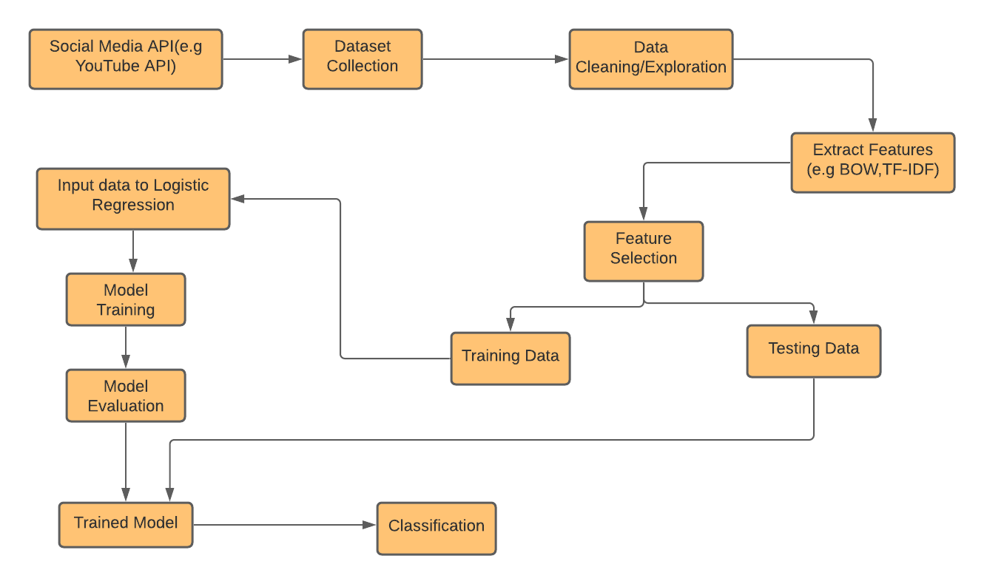

**Figure 5.1: Proposed Approach**



## Dataset Exploration

In this step, we explored our dataset ie Checker and found that the dataset was imabalanced by the ratios of real and fake news e.g. 70 % real news and 60 % fake news. Due to which the dataset was unstable to deal.

Following is the dataset schema:

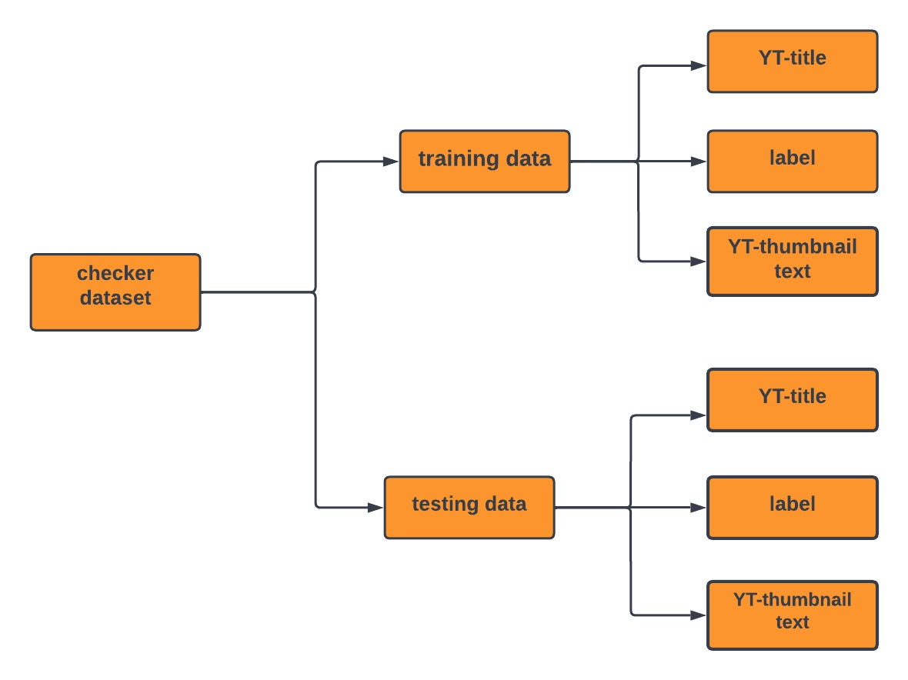

## Data Augmentation and Pre-Processing

In this step, we will try to solve issues in our dataset using data augmentation and different data pre-processing techniques. The main issue in dataset was that the data was not properly distributed as the above dataset schema shows. The file contains 2 different modules as title, text and label. First create dictionaries as title\_dict, text\_dict and label\_dict both for training and testing files. After creating these dictionaries files, create the lists to help us to sort out the specific dataset in the whole file. After creating lists, remove the stop words from both headlines and articles list in training and testing files to clean the dataset. After cleaning the dataset, the dataset was ready to be processed by the logistic regression to classify the news.

# Chapter 6

# Implementation & Results

**Chapter 6: Implementation & Results**

We have implemented machine learning techniques on Checker Videos Detection Dataset and also on Misinformation of videos detection. Following are the techniques:

* Logistic Regression
* Decision Tree Classifier
* Support Vector Machine
* Naïve Bayes Algorithm
* Random Forest Classifier

|  |  |  |  |  |  |  |  |  |  |  |  |  |
| --- | --- | --- | --- | --- | --- | --- | --- | --- | --- | --- | --- | --- |
|  | **Checker Dataset** | | | | **Misinformation Dataset** | | | | **Fake News Detection** | | | |
|  | **Video Classification Dataset** | | | | | | | | **Text Classification Dataset** | | | |
|  | **NLP Models** | | | | | | | | | | | |
| **Machine Learning Algorithms** | **Bow** | **Bow\_Tfidf** | **Bag\_Ngram** | **Bag\_Ngrams\_Tfidf** | **Bow** | **Bow\_Tfidf** | **Bag\_Ngrams** | **Bag\_Ngrams\_Tfidf** | **Bow** | **Bow\_Tfidf** | **Bag\_Ngrams** | **Bag\_Ngrams\_Tfidf** |
| **Decision Tree Classifier** | 77.35% | 77.97% | 77.20% | 76.81% | 80.58% | 78.51% | 85.95% | 76.45% | 97.80% | 95.80% | 97.60% | 93.20% |
| **Support Vector Machine** | 78.68% | 78.81% | 77.93% | 77.11% | 78.79% | 77.69% | 84.57% | 73.83% | 97.60% | 95.73% | 95.87% | 93.60% |
| **Naïve Bayes** | 79.34% | 79.22% | 78.30% | 77.26% | 77.89% | 77.27% | 83.88% | 72.52% | 97.50% | 95.70% | 95.00% | 93.80% |
| **Random Forest Classifier** | 79.74% | 79.48% | 78.52% | 77.35% | 77.36% | 77.02% | 83.47% | 71.74% | 97.44% | 95.68% | 94.48% | 93.92% |
| **Logistic Regression** | 82.10% | 81.56% | 80.94% | 80.40% | 80.99% | 77.69% | 88.43% | 73.55% | 97.20% | 92.40% | 98.80% | 89.60% |

1. Different components of your proposed approach

There are 2 different components of our proposed approach:

* Video to Text Classification
* Text to Text Classification

In both components, we have applied the machine learning algorithms. In video, and text classification, we have gathered the fake thumbnail text and title of YouTube video to perform classification of content.

1. Implementation of proposed approach

In our proposed framework, as illustrated in Figure, we are expanding on the current literature by introducing ensemble techniques with various linguistic feature sets to classify news articles from multiple domains as true or fake. The ensemble techniques along with Linguistic Inquiry and Word Count (LIWC) feature set used in this research are the novelty of our proposed approach.

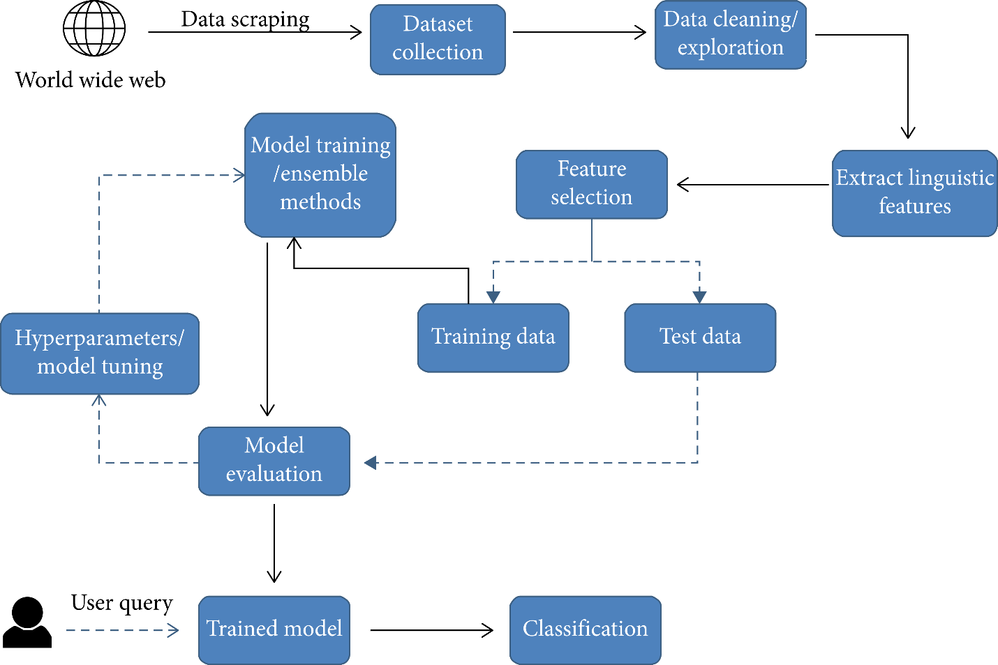

There are numerous reputed websites that post legitimate news contents, and a few other websites such as PolitiFact and Snopes which are used for fact checking. In addition, there are open repositories which are maintained by researchers to keep an up-to-date list of currently available datasets and hyperlinks to potential fact checking sites that may help in countering false news spread. However, we selected three datasets for our experiments which contain news from same domain and contain a mix of both truthful and fake articles. The datasets are available online and are extracted from the World Wide Web. The first dataset is Fake News Dataset which is publicly available at kaggle; the second one is Checker Dataset for ClickBait Thumbnail Detection and the third one is Misinformation on YouTube Videos.

The corpus collected from the World Wide Web is preprocessed before being used as an input for training the models. The unwanted columns such as authors, date posted, URL, and category etc. are filtered out. Columns with no nan values or containing no text or having less than 20 words in the article body are also removed. These operations are performed on all the datasets to achieve consistency of format and structure. Only 4 columns were used in each dataset in form of a dataframe which are ID, Title, Text of article/Captions of Videos/Thumbnails text, Labels(fake/real).

Once the relevant attributes are selected after the data cleaning and exploration phase, the next step involves extraction of the linguistic features. Linguistic features involved certain textual characteristics converted into a numerical form such that they can be used as an input for the training models. These features include percentage of words implying positive or negative emotions; percentage of stop words; punctuation; function words; informal language; and percentage of certain grammar used in sentences such as adjectives, preposition, and verbs. To accomplish the extraction of features from the corpus, we used different NLP models i.e word count based models(e.g bag of words, and bag of n-grams) which classifies the text into different discrete and continuous variables. These models extract different features from any given text. As all of the features extracted using the model are numerical values, no encoding is required for categorical variables.The input features are then used to train the different machine learning models. Each dataset is divided into training and testing set with a 70/30 split, respectively. The articles are shuffled to ensure a fair allocation of fake and true articles in training and tests instances.

The learning algorithms are trained with different hyperparameters to achieve maximum accuracy for a given dataset, with an optimal balance between variance and bias. Each model is trained multiple times with a set of different parameters using a grid search to optimize the model for the best outcome. Using a grid search to find the best parameters is computationally expensive however, the measure is taken to ensure the models do not overfit or underfit the data.



## Tools and Techniques

We have used pyCharm tool for our code work and used following machine learning techniques:

* **Logistic Regression:**

Logistic regression is a process of modeling the probability of a discrete outcome given an input variable. The most common logistic regression models a binary outcome; something that can take two values such as true/false, yes/no, and so on. We have used this model to classify our dataset.

* **Decision Tree Classifier:**

Decision Tree algorithm belongs to the family of supervised learning algorithms. Unlike other supervised learning algorithms, the decision tree algorithm can be used for solving **regression and classification problems** too.

The goal of using a Decision Tree is to create a training model that can use to predict the class or value of the target variable by **learning simple decision rules** inferred from prior data(training data).

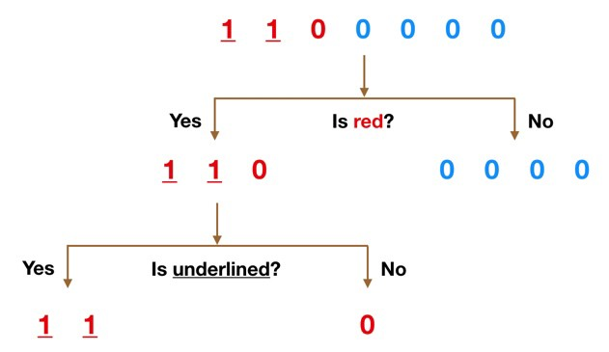

* **Support Vector Machine:**

Support Vector Machine” (SVM) is a supervised [machine learning algorithm](https://courses.analyticsvidhya.com/courses/introduction-to-data-science-2?utm_source=blog&utm_medium=understandingsupportvectormachinearticle) that can be used for both classification or regression challenges. However,  it is mostly used in classification problems. In the SVM algorithm, we plot each data item as a point in n-dimensional space (where n is a number of features you have) with the value of each feature being the value of a particular coordinate. Then, we perform classification by finding the hyper-plane that differentiates the two classes very well (look at the below snapshot).

[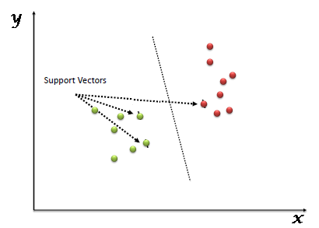](https://www.analyticsvidhya.com/wp-content/uploads/2015/10/SVM_1.png)

* **Naïve Bayes Algorithm:**

Naive Bayes text classifier is based on the [Bayes’s Theorem](https://en.wikipedia.org/wiki/Bayes%27_theorem" \t "_blank), which helps us compute the conditional probabilities of occurrence of two events based on the probabilities of occurrence of each individual event, encoding those probabilities is extremely useful.

* **Random Forest Classifier:**

Random forest, like its name implies, consists of a large number of individual decision trees that operate as an [ensemble](https://en.wikipedia.org/wiki/Ensemble_learning). Each individual tree in the random forest spits out a class prediction and the class with the most votes becomes our model’s prediction (see figure below).

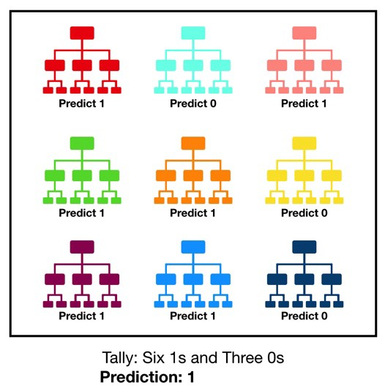

## Best Practices / Coding Standards

After applying the above mentioned machine learning techniques, we get to know that Logistic Regression and Naïve Bayes Algorithm gives better results than other classifier in case of text classification. In video classification, Support Vector Machine gives better results than other algorithms as you can see in above results table. The NLP models which we would prefer would be Bagofwords with TFIDF vectorizer and Bagofngrams with TFIDF vectorizer. They both extracts best features from the dataset and they are ready to be trained in model.

# Chapter 7

# Business Plan

**Chapter 7:** Business Plan

2. 2. Business Description

We are creating a system to detect fake news on academic social media content using NLP and Machine Learning models. This system will be available on a web application, so that the different companies and researchers can use it. Moreover this system will be part of a project, which is an android app. Using that platform anyone can use our system.

## Market Analysis & Strategy

As an increasing hype and use of social media platforms, more and more people tend to hunt out and consume news from social media instead of traditional news organizations whether these news are from academic side or from entertainment point of view. So we don’t have any proper detection system to check whether the scientific content is fake or not, that’s why we are trying to build a system which will help to distinguish from valid and invalid content.

## Competitive Analysis

Currently we have some datasets like Buzzfeed News, LIAR , BS Detector and FNC-1 etc. These datasets have been widely used in different research papers for determining the veracity of news. We have used FNC-1 dataset for our demo work, but later we will create our own dataset.

## Products/Services Description

Designing a system that will detect the academic social media news as fake or real. We are trying to check whether the existing technologies are applicable to authenticate the scientific content or not.

## SWOT Analysis

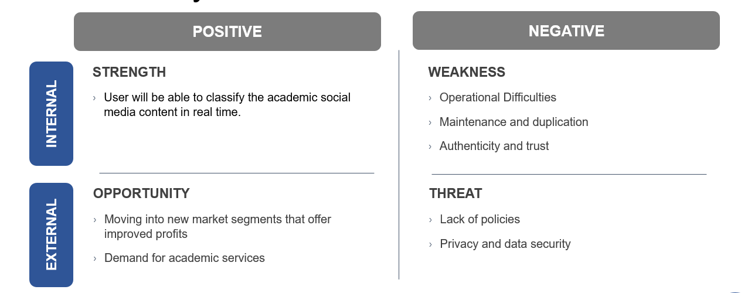

# Chapter 8

# Conclusion & Future Work

**Chapter 8:** Conclusion & Future Work

1. 1. Achievements and Improvements

We have achieved more than 2% accuracy in text to text classification of the research paper Fake News Detection: A Deep Learning Approach whose accuracy was upto 94.2% and our accuracy is 97.6%. They have used deep learning models and we have used machine learning models to classify the content. In video-text classification, we have achieved 82.25% of accuracy. We have created a multimodal for both text and video classification using the existing machine learning and NLP techniques.

* 1. Critical Review

The task of classifying news manually requires in-depth knowledge of the domain and expertise to identify anomalies in the content in any form. In this research, we discussed the problem of classifying fake news on social media from academic point of view using machine learning models. The data we used in our work is collected from the World Wide Web and contains dataset from various domains to cover most of the news. The primary aim of the research is to build a system that will identify that whether the existing techniques are applicable to be used on both academic or entertainment domain. We extracted different textual features from the articles using bag of words (BOW) model and used the feature set as an input to the logistic regression model. The learning models were trained and parameter-tuned to obtain optimal accuracy. Some models have achieved comparatively higher accuracy than others. Fake news detection has many open issues that require attention of researchers. For instance, in order to reduce the spread of fake news, identifying key elements involved in the spread of news is an important step. Deep learning and machine learning techniques can be employed to identify the key sources involved in spread of fake news. We intend to build our own dataset which will be kept up to data according to the latest news in future.

* 1. Future Enhancements/Recommendations

Social media is a huge platform to get the work done in future. In our opinion, fake audio detection should be done on social media platforms to avoid fake news. The future direction lies to improvise and outstretch the existing work for implementation of existing work towards building an automated system for e-commerce websites, where detection of fake news has become equally important.

# 

# 

# Appendices

# Appendix A: Information / Promotional Material

* 1. **Standee (if any)**

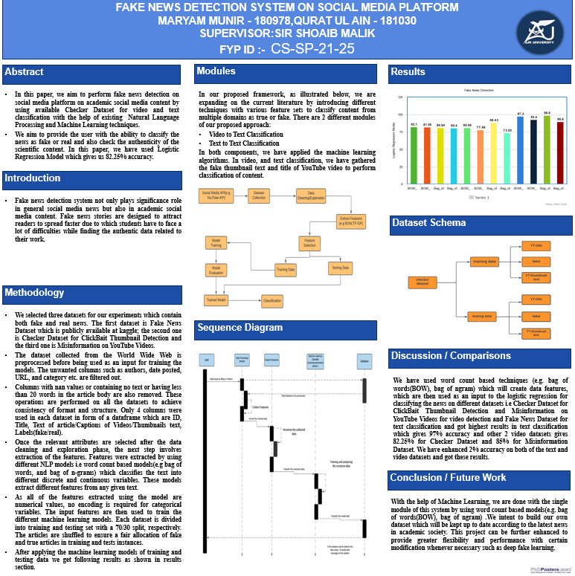

## References

[1]Xie, T., Le, T., Lee, D. (2021). CHECKER: Detecting Clickbait Thumbnails with Weak Supervision and Co-teaching. In: Dong, Y., Kourtellis, N., Hammer, B., Lozano, J.A. (eds) Machine Learning and Knowledge Discovery in Databases. Applied Data Science Track. ECML PKDD 2021. Lecture Notes in Computer Science(), vol 12979. Springer, Cham. https://doi.org/10.1007/978-3-030-86517-7\_26

[2]Singhania S., Fernandez N., Rao S. (2017) 3HAN: A Deep Neural Network for Fake News Detection. In: Liu D., Xie S., Li Y., Zhao D., El-Alfy ES. (eds) Neural Information Processing. ICONIP 2017. Lecture Notes in Computer Science, vol 10635. Springer, Cham. <https://doi.org/10.1007/978-3-319-70096-0_59>

[3]Saikh T., Anand A., Ekbal A., Bhattacharyya P. (2019) A Novel Approach Towards Fake News Detection: Deep Learning Augmented with Textual Entailment Features. In: Métais E., Meziane F., Vadera S., Sugumaran V., Saraee M. (eds) Natural Language Processing and Information Systems. NLDB 2019. Lecture Notes in Computer Science, vol 11608. Springer, Cham. <https://doi.org/10.1007/978-3-030-23281-8_30>

[4] Jwa, H., Oh, D., Park, K., Kang, J. M., & Lim, H. (2019). exBAKE: Automatic fake news detection model based on Bidirectional Encoder Representations from Transformers (BERT). Applied Sciences (Switzerland), 9(19), [4062]. <https://doi.org/10.3390/app9194062>

[5] Thota, Aswini; Tilak, Priyanka; Ahluwalia, Simrat; and Lohia, Nibrat (2018) "Fake News Detection: A Deep Learning Approach," SMU Data Science Review: Vol. 1 : No. 3 , Article. Available at: <https://scholar.smu.edu/datasciencereview/vol1/iss3/10>